**Creating Microservices for Account & Loan**

**PART 1: ACCOUNT MICROSERVICE (PORT 8080)**

**Step 1: Project Setup**

* Visit: <https://start.spring.io>
* Fill in the following:
  + **Group:** com.cognizant
  + **Artifact:** account
* Select Dependencies:
  + Developer Tools → **Spring Boot DevTools**
  + Web → **Spring Web**
* Click **Generate**
* Extract and place it inside:  
  **D:\6376614\ microservices\account**

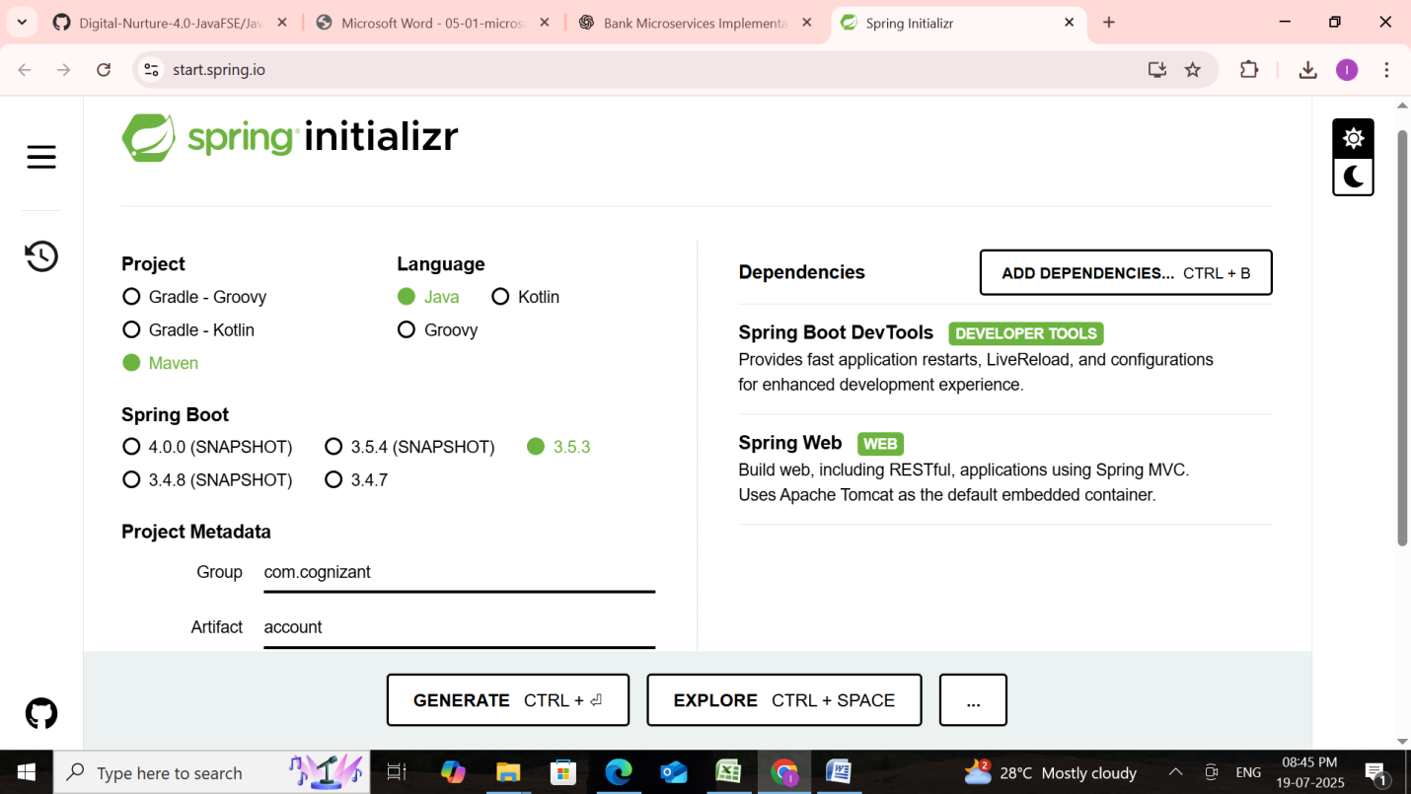

**Step 2: Build the Project**

Open Command Prompt:

**cd D:\6376614\microservices\account**

**mvn clean package**

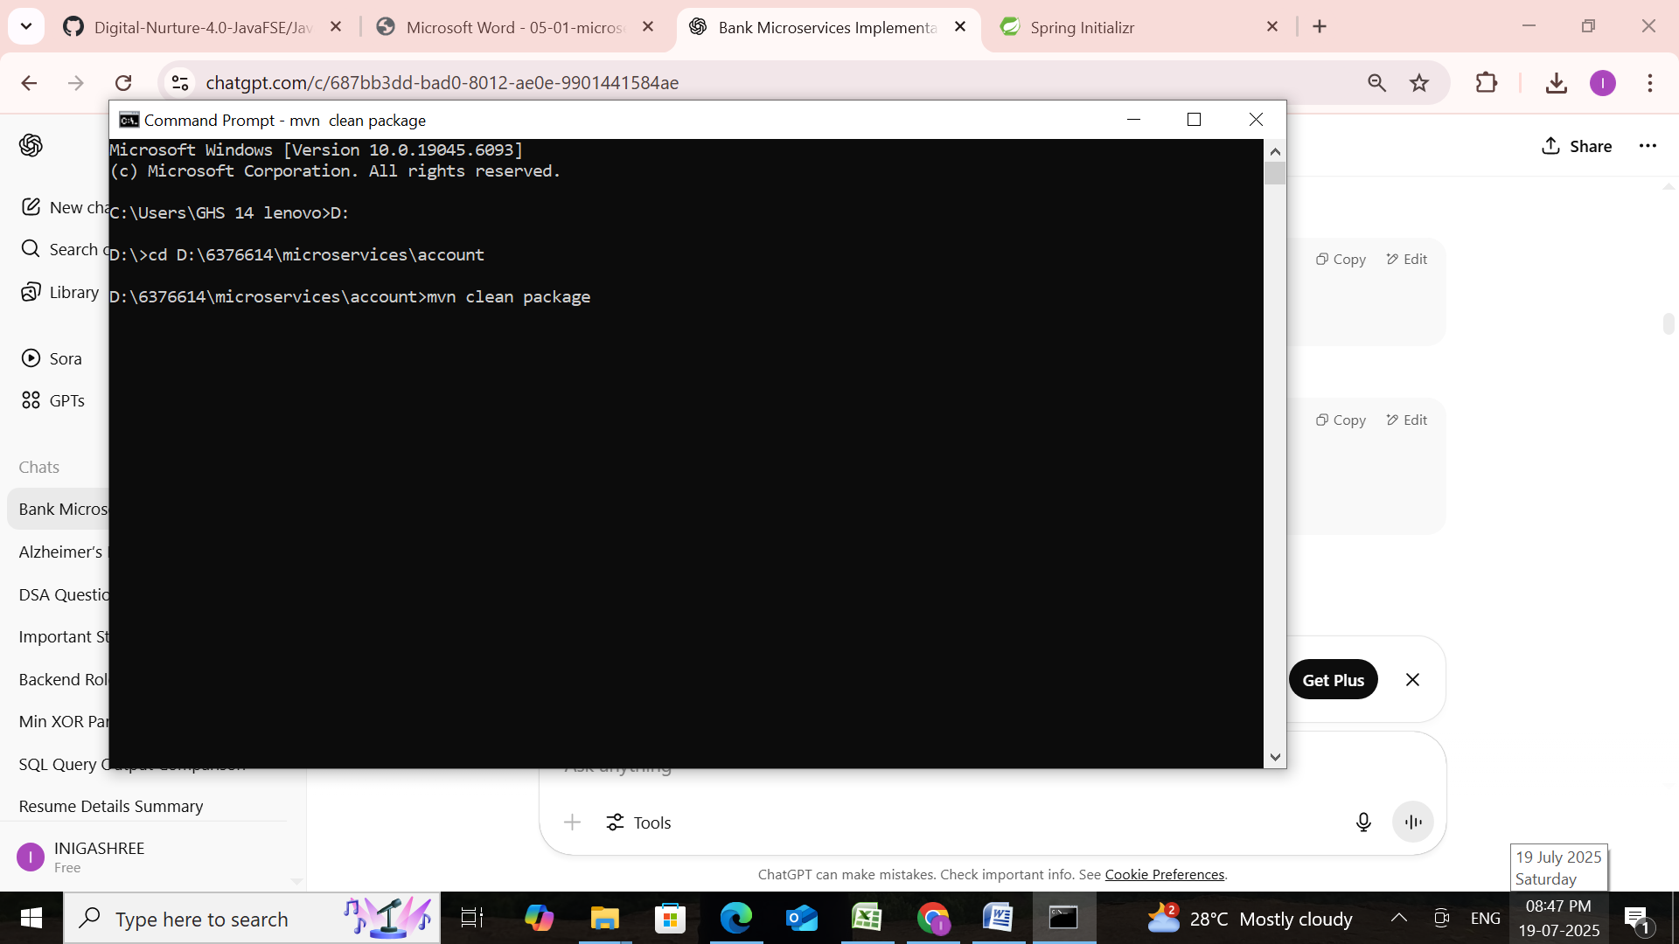

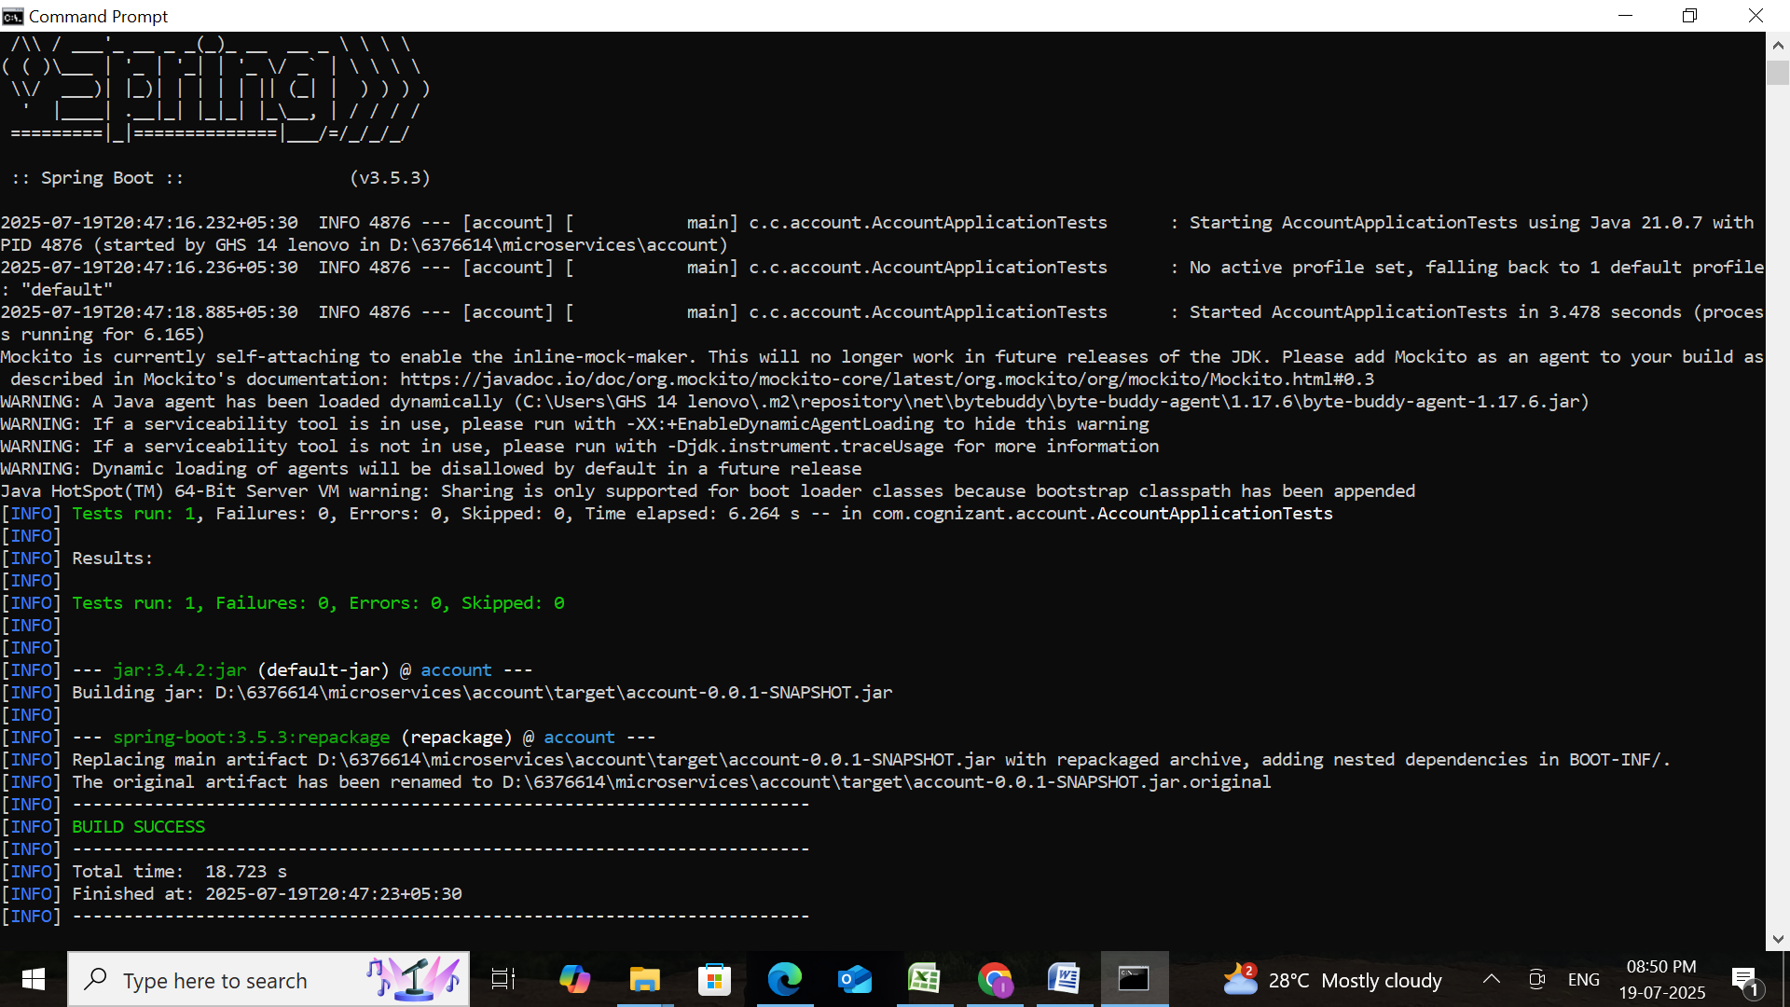

**Step 3: Import to Intellij**

* Open Intellij IDE
* Go to **File → Import → Existing Maven Project**
* Browse to: **D:\6376614\microservices\account**
* Click **Finish**

**Step 4: Create Controller**

**Location:** src/main/java/com/cognizant/account/controller/AccountController.java

**AccountController.java**

package com.cognizant.account.controller;  
  
import org.springframework.web.bind.annotation.*;  
  
import java.util.Map;  
  
@RestController  
@RequestMapping("/accounts")  
public class AccountController {  
  
 @GetMapping("/{number}")  
 public Map<String, Object> getAccountDetails(@PathVariable String number) {  
 return Map.*of*(  
 "number", number,  
 "type", "savings",  
 "balance", 234343  
 );  
 }  
}

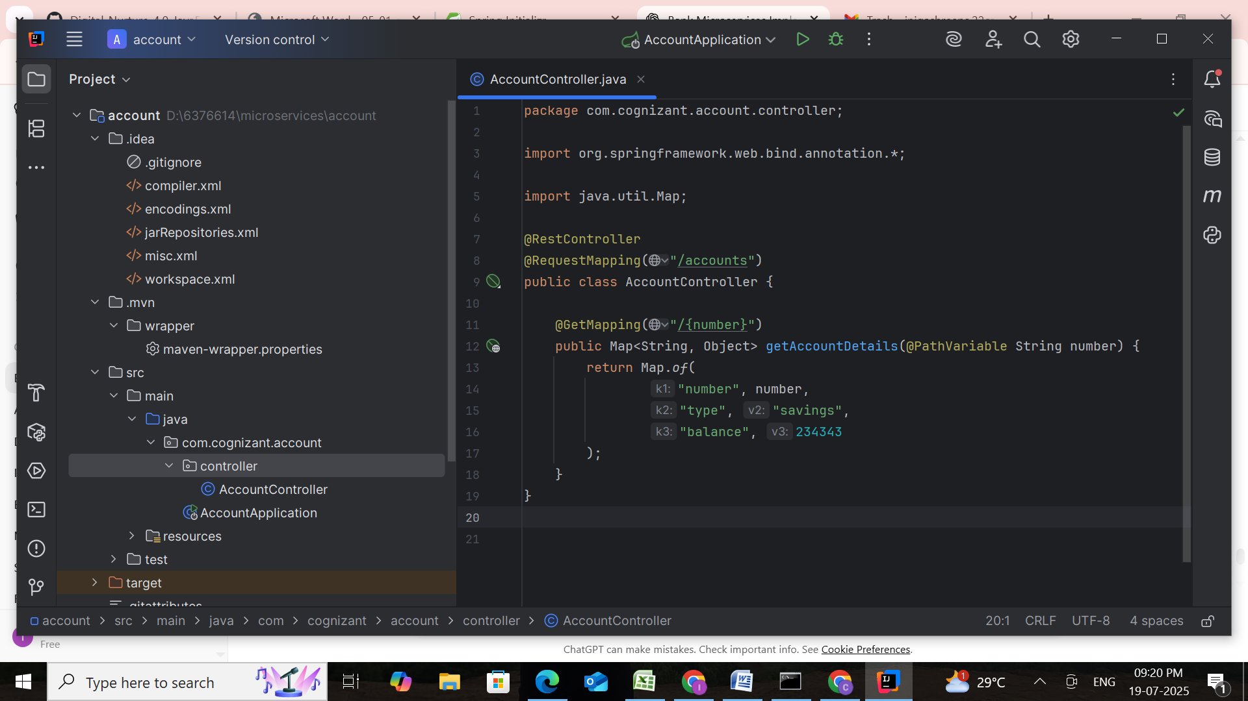

### Step 5: Run and Test

* Run AccountApplication.java
* Visit URL:  
  http://localhost:8080/accounts/00987987973432

**AccountApplication.java**

package com.cognizant.account;  
  
import org.springframework.boot.SpringApplication;  
import org.springframework.boot.autoconfigure.SpringBootApplication;  
  
@SpringBootApplication  
public class AccountApplication {  
 public static void main(String[] args) {  
 SpringApplication.*run*(AccountApplication.class, args);  
 }  
}

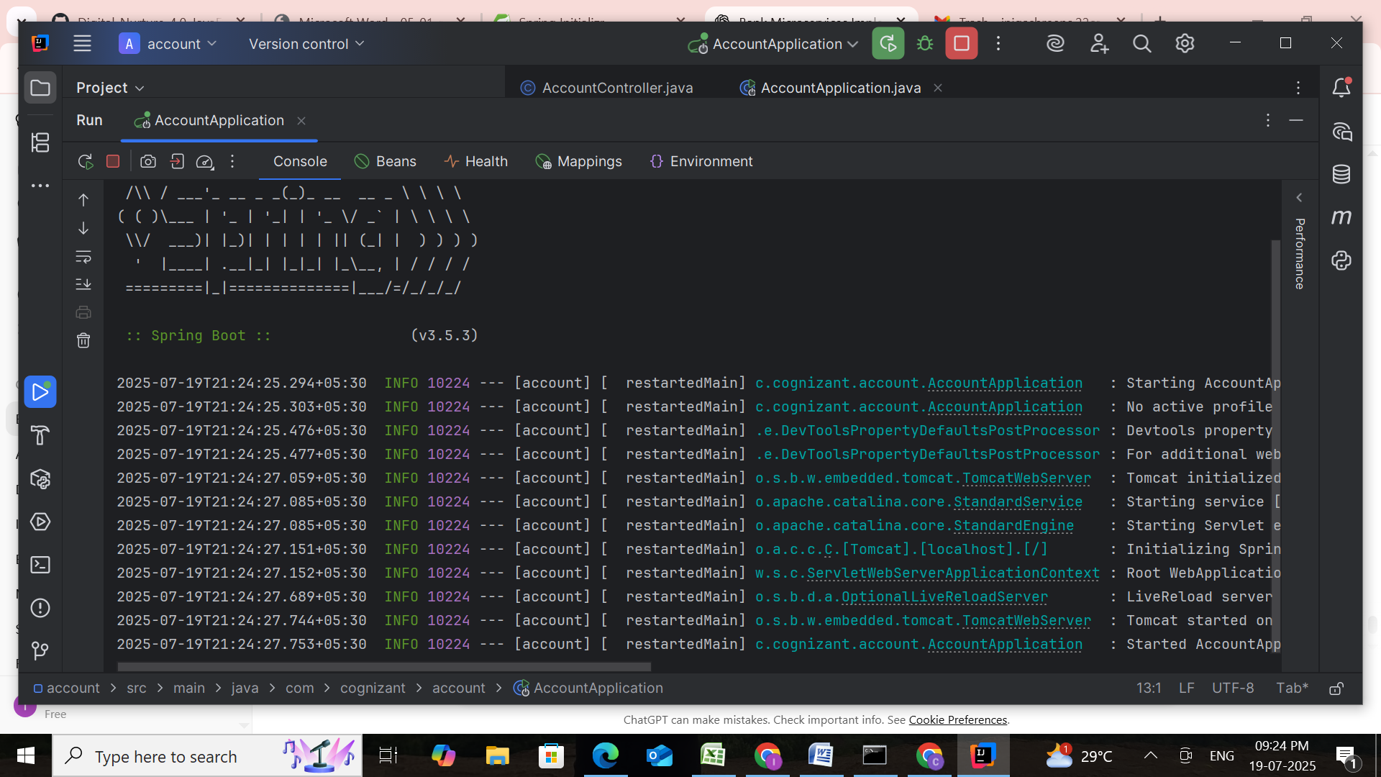

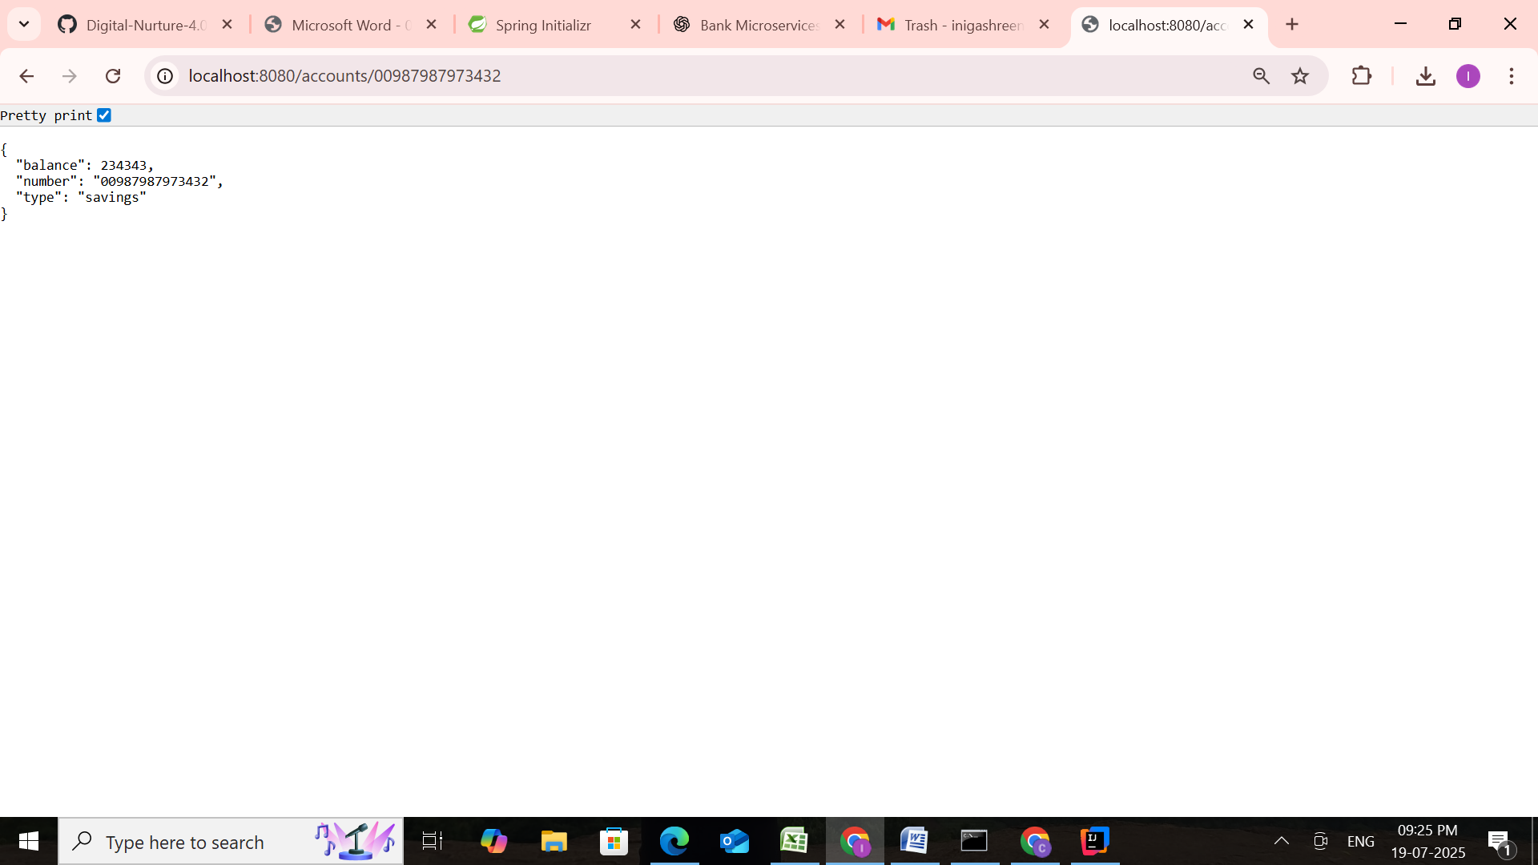

**PART 2: LOAN MICROSERVICE (PORT 8081)**

### Step 1: Project Setup

Repeat steps at <https://start.spring.io>

* **Group:** com.cognizant
* **Artifact:** loan
* Dependencies:
  + **Spring Boot DevTools**
  + **Spring Web**

Extract and place it inside:  
**D:\6376614\microservices\loan**

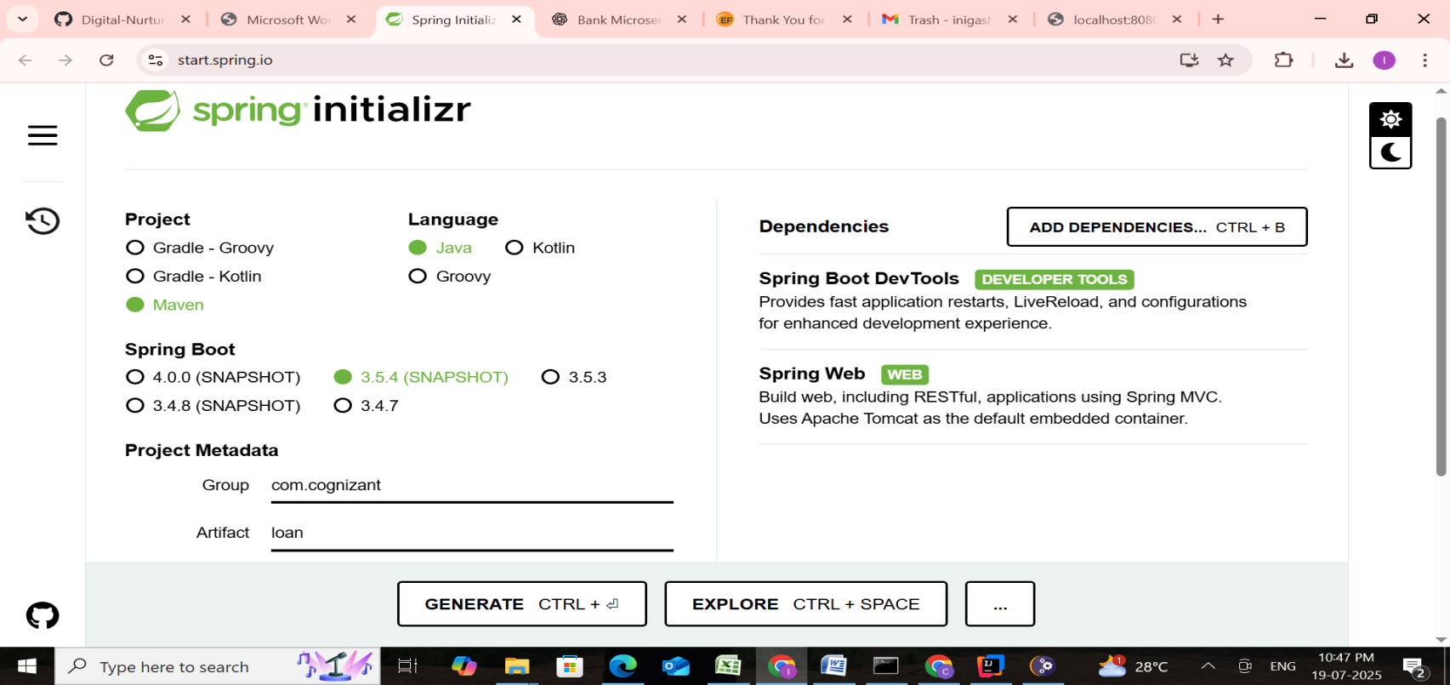

### Step 2: Build the Project

**cd D:\6376614\microservices\loan**

**mvn clean package**

### Step 3: Import to Intellij

* **File → Import → Existing Maven Project**
* Browse:  
  **D:\6376614\microservices\loan**
* Finish import

### Step 4: Change Default Port

In src/main/resources/application.properties, add:

**server.port=8081**

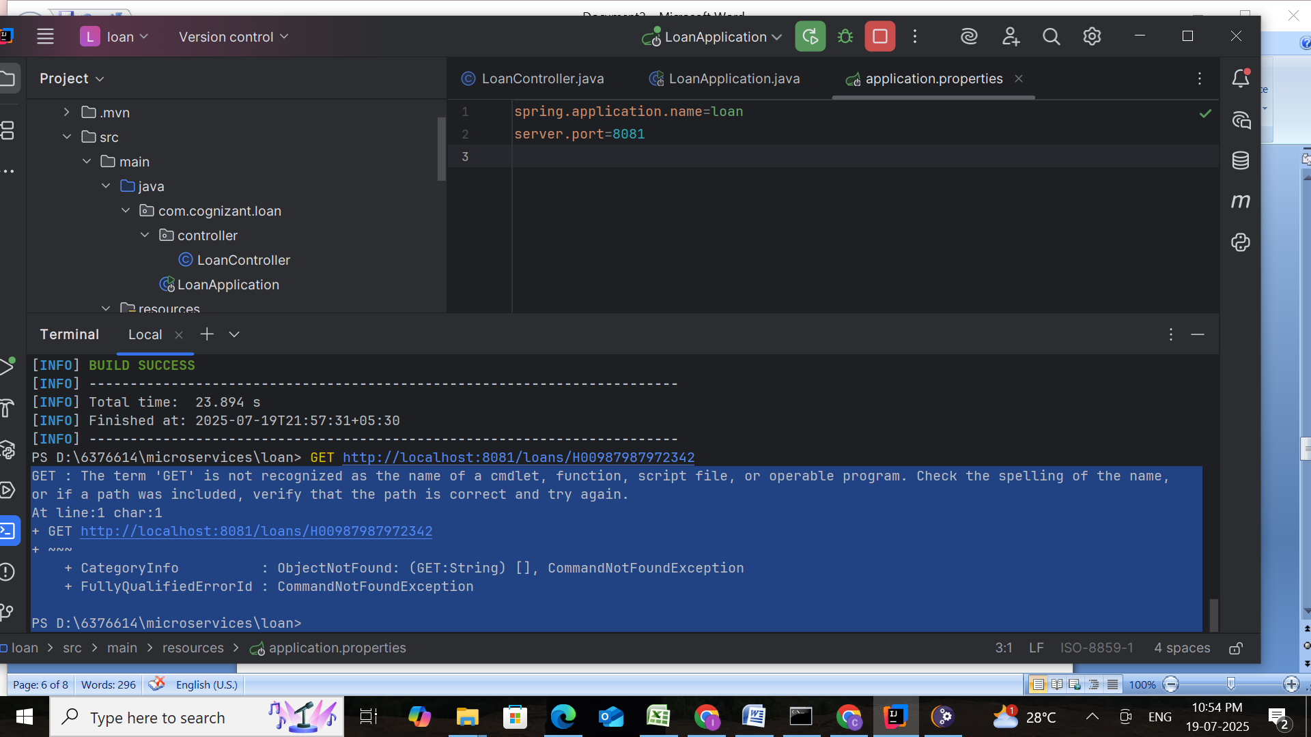

### Step 5: Create Controller

**Location:** src/main/java/com/cognizant/loan/controller/LoanController.java

**LoanController.java**

package com.cognizant.loan.controller;  
  
import org.springframework.web.bind.annotation.*;  
  
import java.util.Map;  
  
@RestController  
@RequestMapping("/loans")  
public class LoanController {  
  
 @GetMapping("/{number}")  
 public Map<String, Object> getLoanDetails(@PathVariable String number) {  
 return Map.*of*(  
 "number", number,  
 "type", "car",  
 "loan", 400000,  
 "emi", 3258,  
 "tenure", 18  
 );  
 }  
}

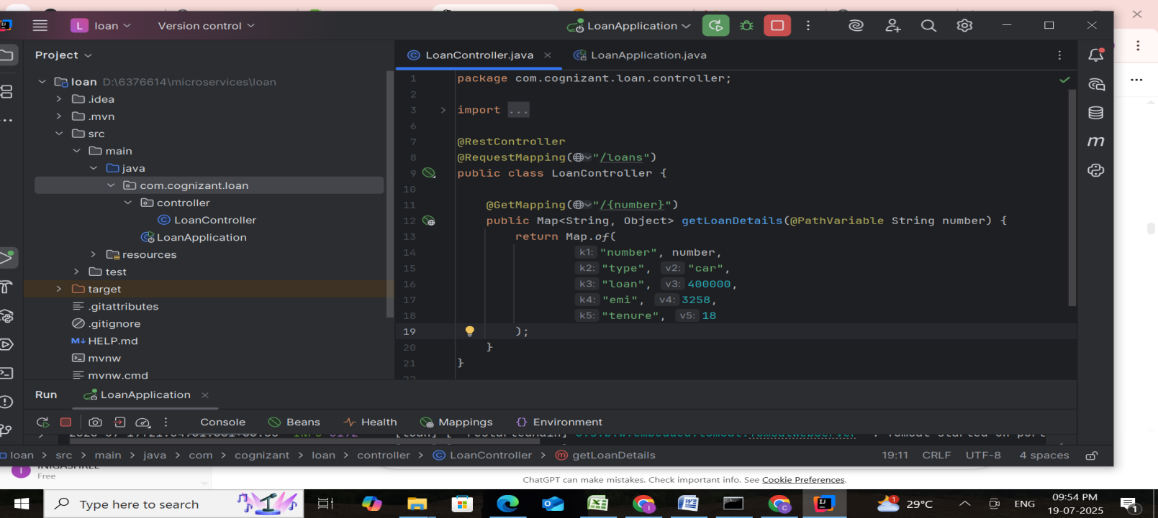

**LoanApplication.java**

package com.cognizant.loan;  
  
import org.springframework.boot.SpringApplication;  
import org.springframework.boot.autoconfigure.SpringBootApplication;  
  
@SpringBootApplication  
public class LoanApplication {  
 public static void main(String[] args) {  
 SpringApplication.*run*(LoanApplication.class, args);  
 }  
}

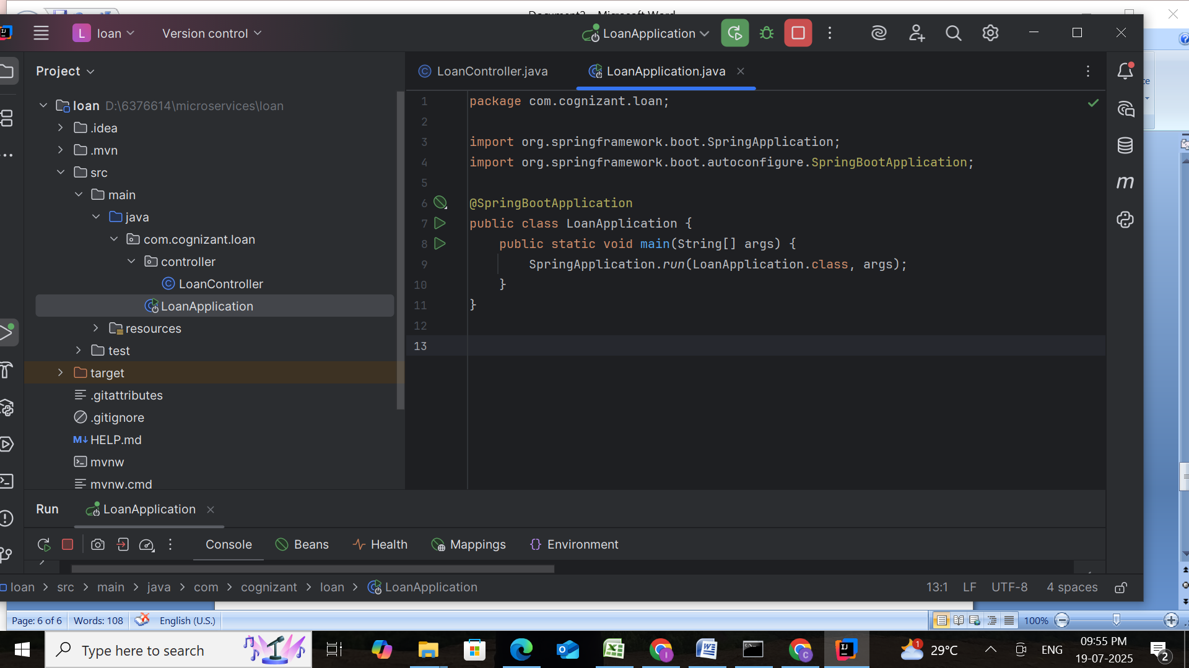

### Step 6: Run and Test

* First, ensure **Account service** is already running.
* Then, run LoanApplication.java
* Visit URL:  
  **http://localhost:8081/loans/H00987987972342**

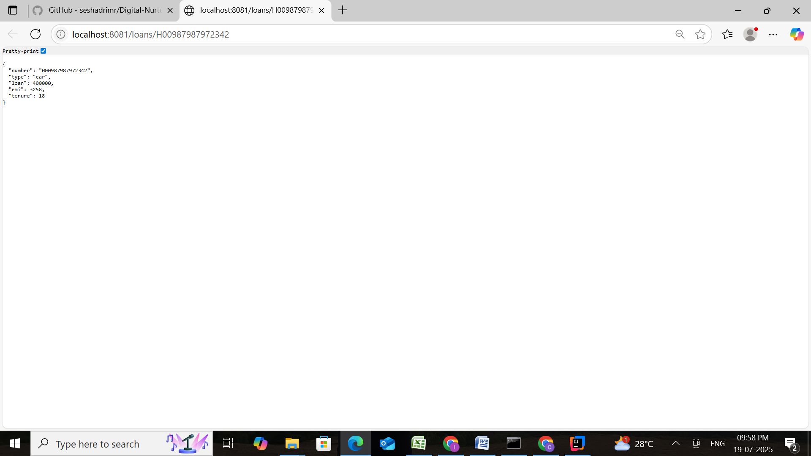

## Final Outcome

Now , we have **two independent microservices** running:

* Account Microservice → Port **8080**
* Loan Microservice → Port **8081**

Each responds to REST API GET requests with hardcoded data.

